**DAILY ONLINE ACTIVITIES SUMMARY**

|  |  |  |  |  |  |  |  |  |
| --- | --- | --- | --- | --- | --- | --- | --- | --- |
| **Date:** | | **02nd June 2020** | | | | | | |
| **Name of the Faculty** | | **VENKATESH** | | | | | | |
| **No. of Students Allotted for monitoring** | | | | | **27** | | | |
| **Progress** | | | | | **Good** | | | |
| **Whether collected report from all the allotted students** | | | | | **27** | | | |
| **Online Test Summary** | | | | | | | | |
| **Subject** |  | | | | | | | |
| **Semester** |  | | | **Duration** | |  | | |
| **No. of students Taken** | | |  | **Passing %** | |  | | |
| **Certification Course Summary** | | | | | | | | |
| **Course** | | 1. **R For Data Analysis** 2. **Webinar on “RESEARCH INNOVATION AND SKILL DEVELOPMENT”** 3. **MICROSOFT FDP ON Basics of Python** 4. **Webinar on Applying Convolutional Neural Networks** 5. **Webinar on ThingSpeak Cloud &IoT** | | | | | | |
| **Certificate Provider** | | 1. **ALISON** 2. **BIT Bellary** 3. **BIT BANGALORE** 4. **PANTECH** 5. **PANTECH** | | | | | **Duration** | 1. **3 Hours** 2. **2 Hours** 3. **2 Hours** 4. **1 Hour** 5. **2 Hour** 6. **2 Hour** |
| **Coding Challenges** | | | | | | | | |
| **Problem Statement: Given an array of positive integers. Write a C Program to find the inversion count of the array.** | | | | | | | | |
| **Status: Total 35 Students were solved.** | | | | | | | | |
| **Uploaded the report in Github** | | | | | **Yes** | | | |
| **If yes Repository name** | | | | | [https://github.com/Venkateshbhat2007/](https://github.com/Venkateshbhat2007/Online-Daily-Activities) | | | |
| **Uploaded the report in slack** | | | | | **Yes** | | | |

# 

**R For Data Analysis by Alison**

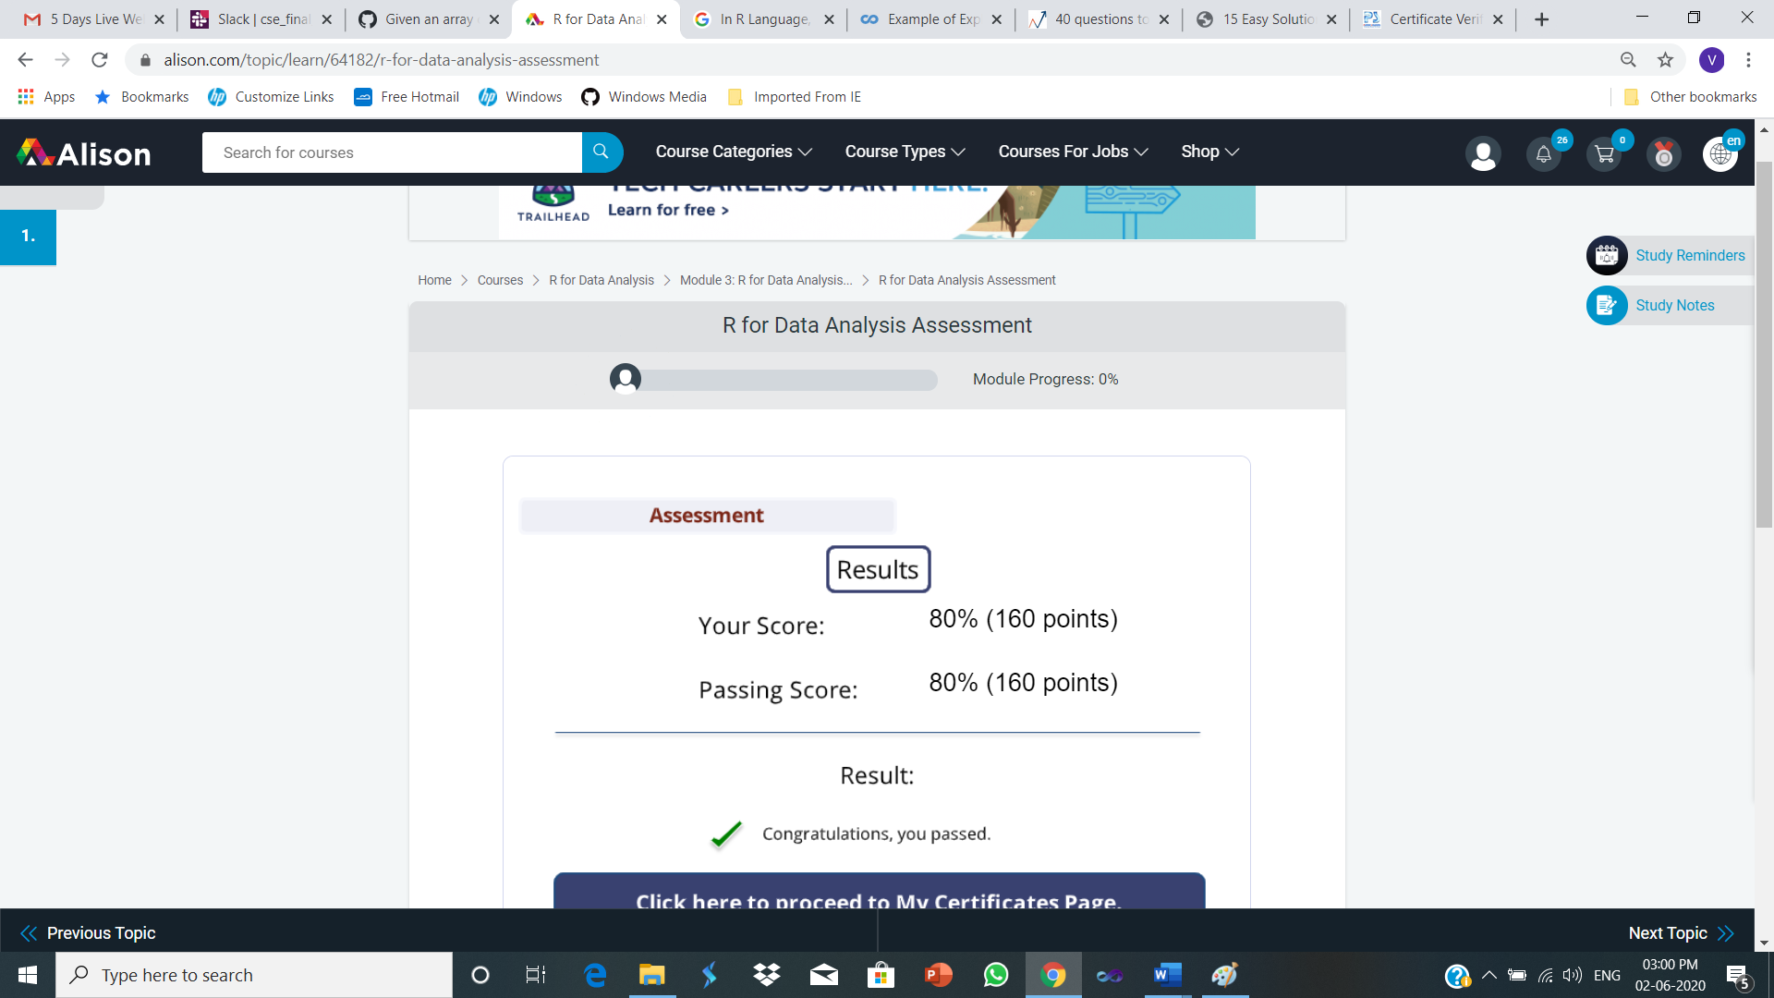

**One Week FDP on Research and Innovation Skill Development**

**By BIT Bellary**

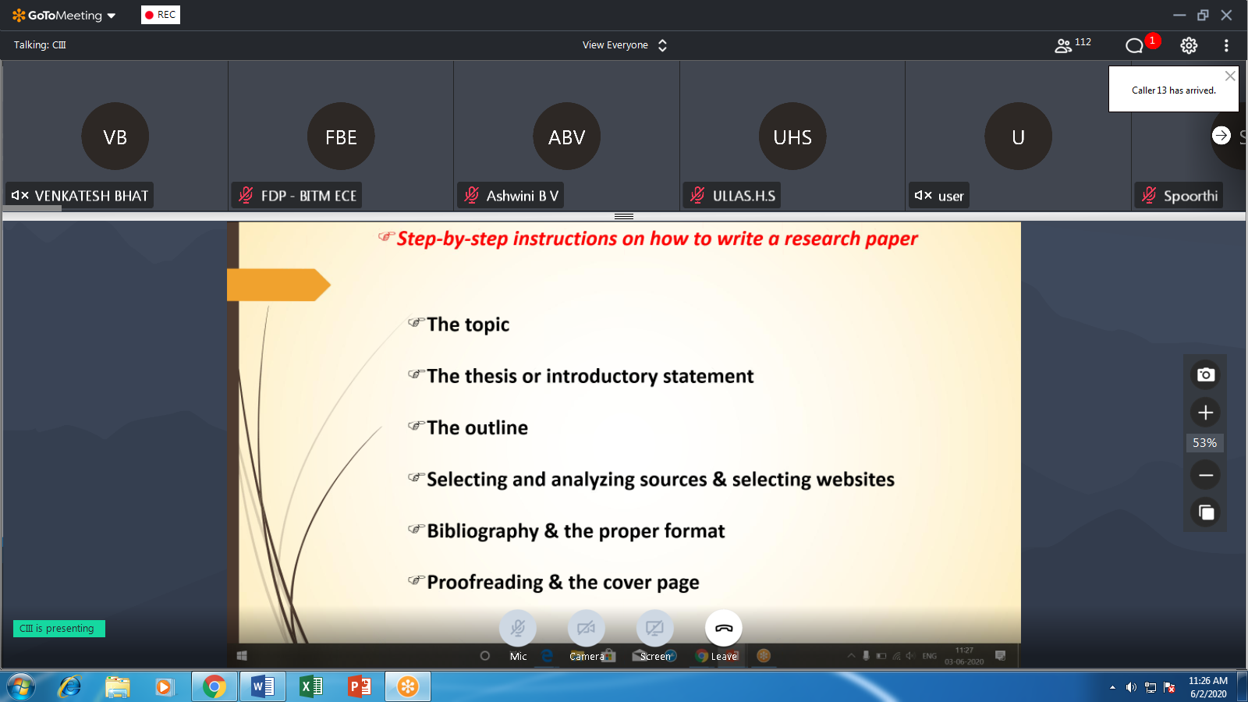

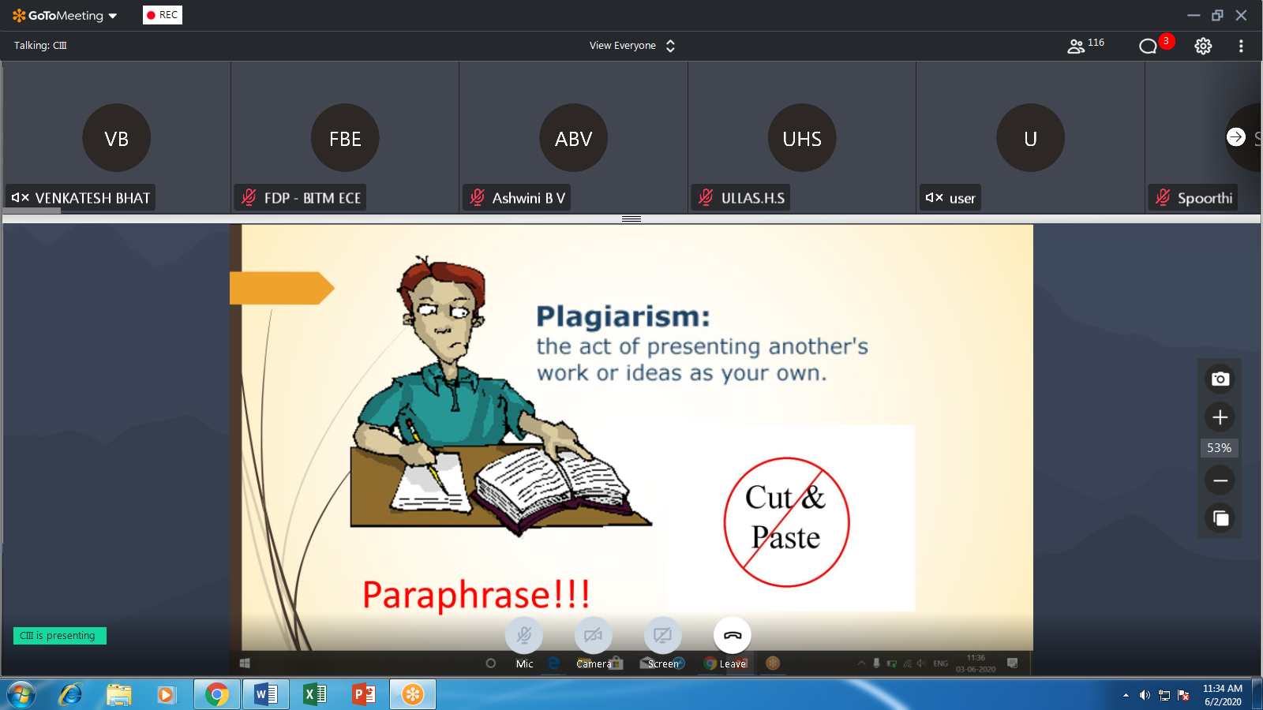

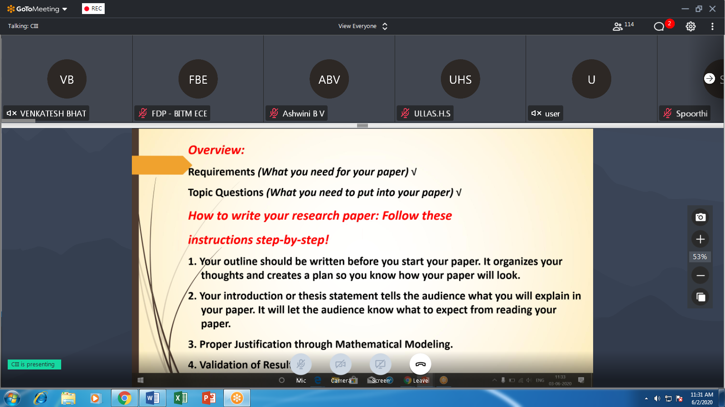

**MICROSOFT FDP ON Basics of Python by BIT Bangalore**

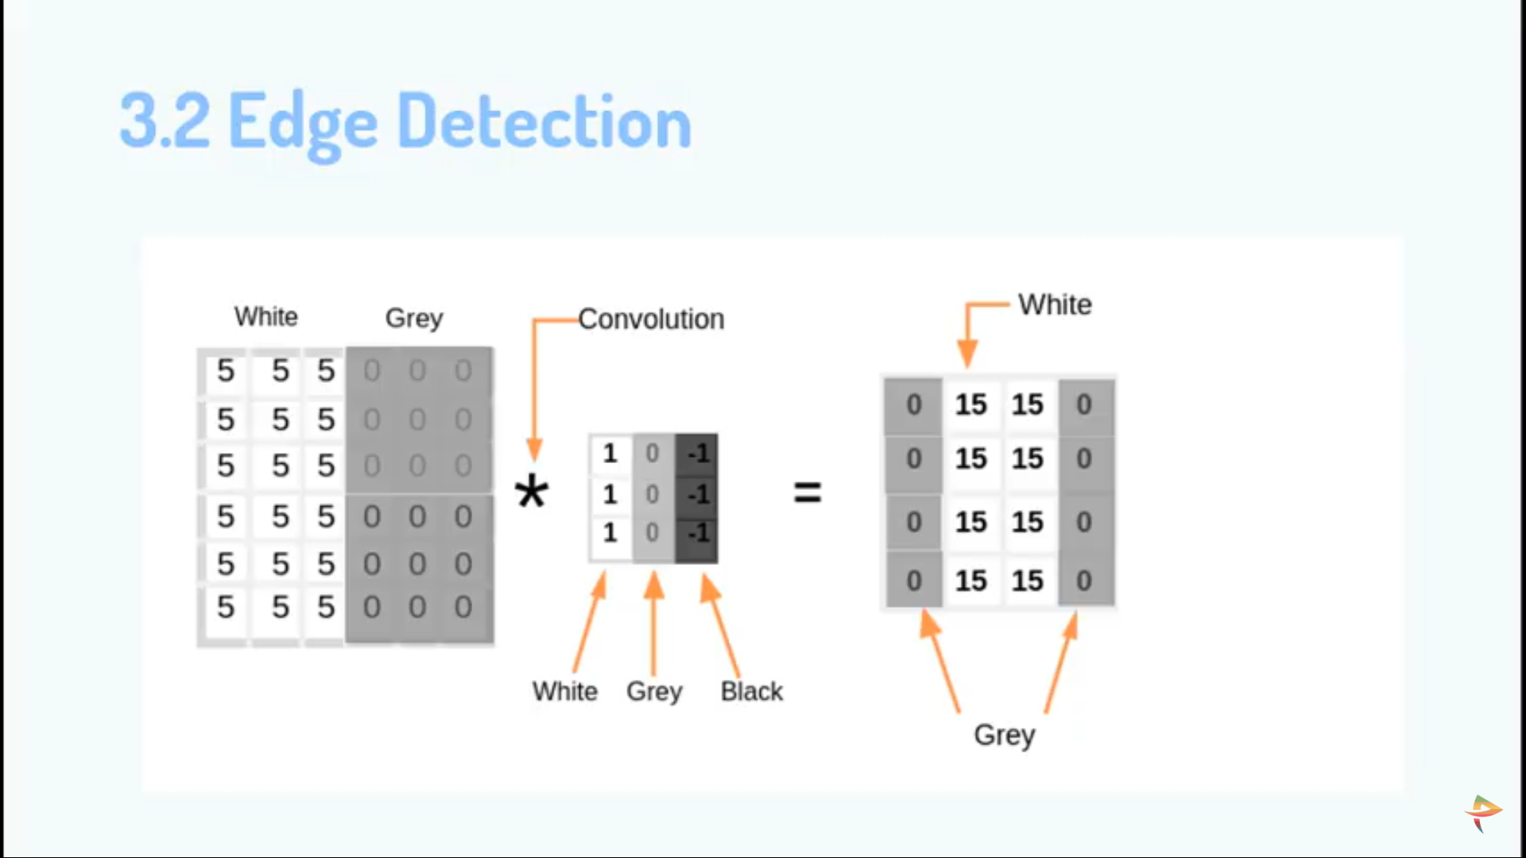

Applying Convolution Neural Network in Deep Learning by PANTECH

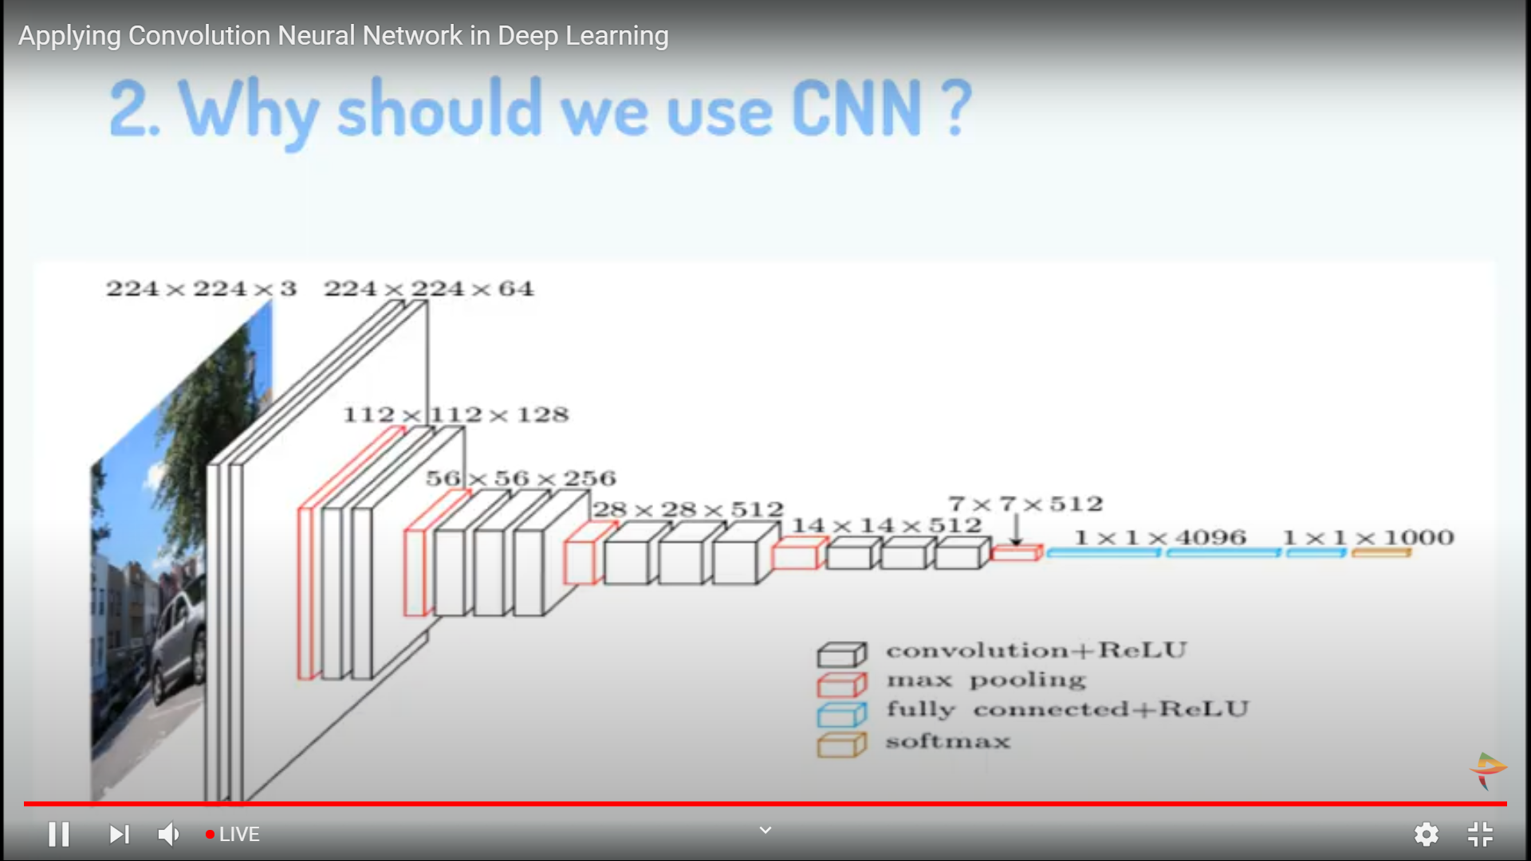

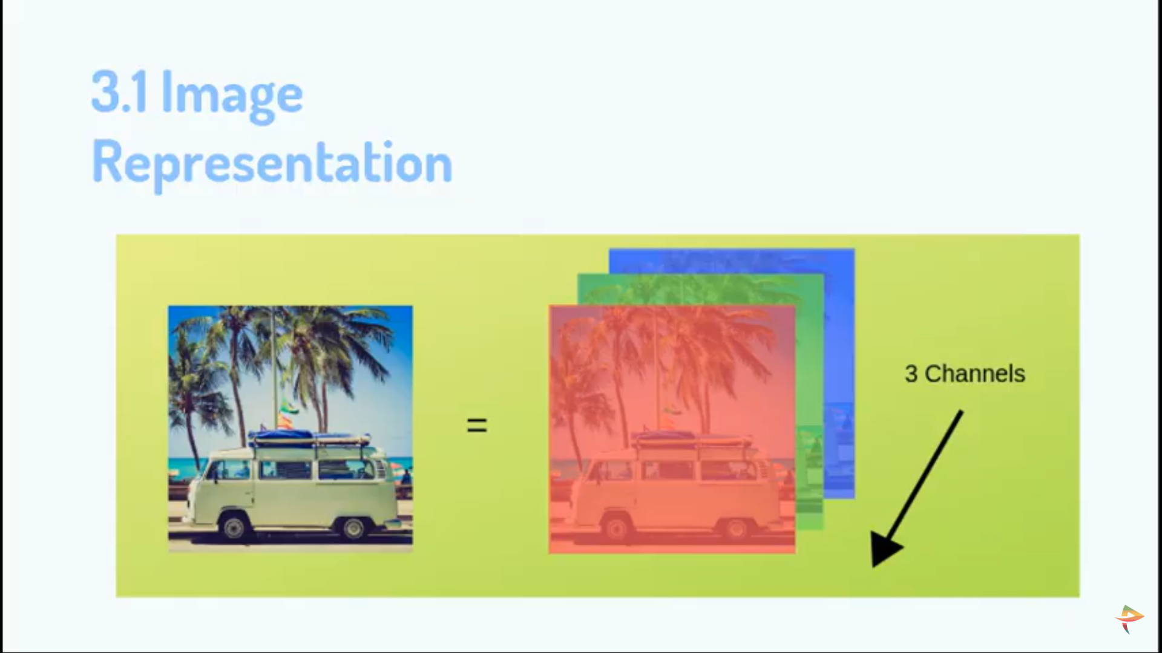

**Webinar on ThingSpeak Cloud &IoT**

**By PANTECH**

